1. Reflect on your experience doing the project using R

When Using R to do my project, I realize there are so many different arrangements of codes, and tidying up dataset is a very tedious and long process. I downloaded a summery data of all year from 2015-2022, but its data collected for 2020 and 2021 is wrong. I found that half way, and fixed it with both R technique and excel matching with another excel which has the correct data.

Different plot asks for different formulation of data too. For example, line graph group must be categorical, If I want to analyze Afghanistan’s 6 factors variation over the year from this graph, I need to rearrange it first.

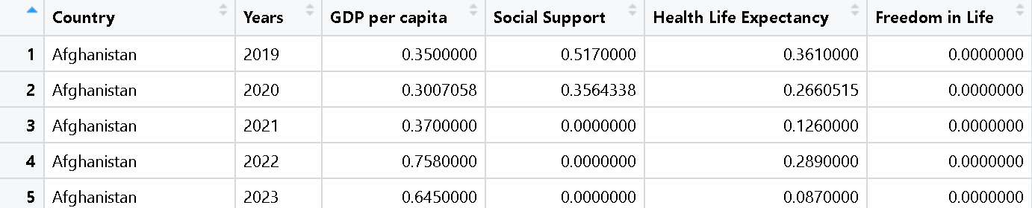

1. What have you learned in NM2207, and how can that be helpful in your future career?

I’m learning statistic, media and psychology. The visualization technique can help me explaining cases to my costumer. It can wither be posted to website, or be downloaded as a pdf file for advertising. In fact, at the beginning I was about to chose a marketing dataset, but most of them are in huge size.

1. Try to identify use-cases within your specialization and future industry that you might benefit by using R.

My future statistic course will keep using R to analysis data, which is beneficial for me to understand it a little bit beforehand. Besides, Website building is useful for building up a personal site with my portfolios, it would be beneficial for seeking job.